Attachment A

BEFORE THE NEW MEXICO PUBLIC REGULATION COMMISSION

APPLICATION FOR APPROVAL OF )
EL PASO ELECTRIC COMPANY'S )
2023 RENEWABLE ENERGY ACT PLAN )
PURSUANT TO THE RENEWABLE ENERGY ) CASE NO. 23-00086-UT
ACT AND 17.9.572 NMAC, AND SEVENTH )
REVISED RATE NO. 38 – RPS COST RIDER )
)
EL PASO ELECTRIC COMPANY, )
Applicant. )
)

NOTICE OF PROCEEDING AND HEARING
NOTICE is hereby given of the following matters pertaining to the above captioned case pending before the New Mexico Public Regulation Commission ("Commission" or "NMPRC"):
On July 5, 2023, El Paso Electric Company ("EPE" or "Company") filed its Annual Renewable Energy Plan for Plan Year 2024 ("Plan" or "Plan for 2024"). This application seeks approval of EPE's “Contingency Plan” for compliance with the New Mexico Renewable Energy Act NMSA 1978, Sections 62-16-1 to -10 (2004, as amended through 2023) ("REA" or "Act"), and the New Mexico Public Regulation Commission's ("NMPRC" or "Commission") Rule 17.9.572 of the New Mexico Administrative Code ("NMAC") ("Rule 572" or "Rule").
EPE's proposed Contingency Plan does not rely on any energy and RECs from EPE's approved Hecate Resources in 2024 to account for the possibility that the Hecate Project experiences delays to COD or other issues. Instead, the Contingency Plan includes energy and RECs from two proposed new procurements – a new DG REC Purchase Program and temporary assignment of a portion of EPE's Texas jurisdictional quantity of solar energy from the approved Buena Vista 1 Project.
EPE requests that the Commission approve its Plan and additionally seeks the following:
- authorization for two new procurements:

  - a new DG REC Purchase Program pursuant to 17.9.572.10(C)(3) NMAC and Section 62-16-5(B) of the REA; and

  - temporary assignment of a portion of EPE's Texas jurisdictional quantity of solar energy from the Buena Vista 1 project for delivery to New Mexico customers and to retire the associated RECs for RPS compliance purposes;

- authorization to recover Commission-approved Contingency Plan procurement costs through the RPS Cost Rider;

- approval of reconciled RPS rider costs and rider revenue collections for the calendar year 2022;

- approval of final reconciliation regarding CRLEF REC payments;

- approval to revise RPS Cost Rider Rate No. 38 from $0.008335 per kilowatt-hour ("kWh") to $0.008372 per kWh, to recover approved 2024 Plan Year costs adjusted for the 2022 reconciliation.

- approval to cancel the following tariffed Rates and Forms related to EPE's former DG REC Purchase Program:

  - Rates No. 33 Small System Renewable Energy Certificate ("REC") Purchase; 34 Medium System REC Purchase; 35 Large System Renewable Energy Certificate Purchase;

  - Form Nos. 33 Application for the Purchase of Small System RECs; 34 Application for the Purchase of Medium System RECs; and 37 Application for the Purchase of Large System RECs;

- approval of a new Rate No 48- Renewable Energy Certificate Purchase Program;

- approval of a variance from the data filing requirements of 17.9.530 NMAC; and such other approvals, authorizations and actions required under the REA, Rule 572, and Commission rules and orders to implement the 2023 Plan and revisions to the RPS Cost Rider.

EPE proposes revisions to Rate No. 38 to recover Plan Year 2024 Portfolio Procurement Costs, including the proposed new procurements, of $15,780,235 reduced by $863,014 of overcollections during 2022 through the RPS Cost Rider, at a rate of $0.008372 per kWh. This new rate is for all applicable retail customers served by EPE and represents an increase of 0.4 percent from the current RPS Cost Rider of $0.008335 (All applicable Retail Rate Schedules).
The following Table shows typical bill impacts resulting from the increase in the RPS Rider for the Residential rate class. These impacts are subject to change by the Commission based upon its findings in this case.
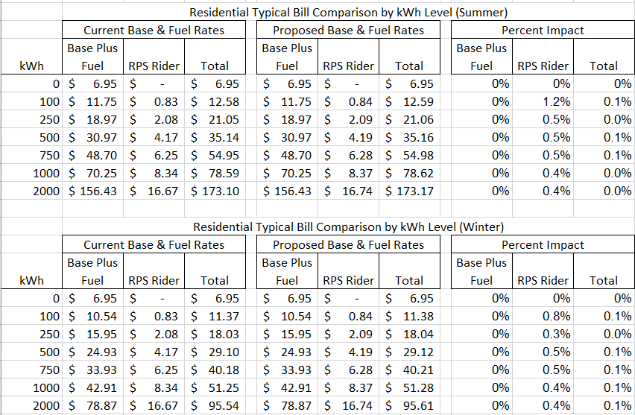
This case has been docketed as Case No. 23-00086-UT, and any inquiries should be referred to that number.
Any interested person may examine EPE's Application and the pre-filed testimonies, exhibits, pleadings and other documents filed in the case online at http://nmprc/state.nm.us under "Case Lookup Edocket", or by making arrangements for an in-person viewing at the Commission offices by calling 1-505-827-6968 during normal business hours, or at EPE's offices, 555 S Compress Rd, Las Cruces, New Mexico, 88005, telephone number (575) 526-5555, or at EPE's website regulatory https://www.epelectric.com/company/public-notices. All inquiries or written comments concerning this matter should refer to Case No. 23-00086-UT.
The procedural schedule for this case is as follows:

- On or before September 18, 2023, EPE shall cause, at its sole expense, the Notice to be published once in a newspaper of general circulation available in every county where EPE provides service in New Mexico. EPE shall ensure that an affidavit confirming such publication is promptly filed in the docket. EPE shall mail (by bill insert or separately at its sole expense) the Notice of Proceeding and Hearing. EPE shall ensure that an affidavit confirming such mailing is promptly filed in the docket.
- EPE shall also post as promptly as feasible to its website, copies of the Notice as well as the Application, and the supporting pre-filed direct testimony, exhibits, and related papers. EPE shall ensure that an affidavit confirming such posting is promptly filed in the docket.
- Any person desiring to become a party (“intervenor”) to this case must file a motion for leave to intervene in conformity with PRC Rules of Procedure 1.2.2.23(A) and 1.2.2.23(B) NMAC on or before October 13, 2023. All motions for leave to intervene shall be served on all existing parties and other proposed intervenors of record.
- Staff shall and any intervenor may file direct testimony by October 13, 2023.
- With regard to EPE’s direct testimony and Staff and intervenors’ testimony, motions in limine, motions to strike, and other prehearing motions shall be filed on or before October 18, 2023. Responses to such motions shall be filed on or before October 24, 2023.
- Any rebuttal testimony shall be filed on or before October 24, 2023.
- Any stipulation entered into among some or all parties may be filed no later than October 27, 2023, together with testimony in support of that stipulation. If Staff is a stipulating party, Staff shall file direct testimony.
- Solely with regard to rebuttal testimony, motions in limine, motions to strike, and other prehearing motions shall be filed on or before noon October 26, 2023. Responses to such motions shall be filed on or before October 27, 2023.
- Any response testimony regarding a stipulation shall be filed by October 30, 2023.
- Service of all documents filed in this proceeding and discovery requests and responses shall be via e-mail unless a party requests a hard copy or unless otherwise ordered. EPE shall post the discovery requests it receives from the parties or Staff and EPE’s responses to discovery requests, including exhibits, on EPE’s file sharing platform.
- Responses to discovery shall be produced by close of business on the date that the certificate of service confirming such production is filed in the record. Discovery responses produced after 5:00 p.m. on the date that the certificate of service is filed shall be deemed produced the following day.
- Responses to discovery requests solely regarding rebuttal testimony shall be served within three (3) days of service of the request unless otherwise agreed or ordered.
- A prehearing conference is tentatively scheduled for October 27, 2023, commencing at 2:00 p.m. Mountain Time (“MT”) on the Zoom videoconference platform. The purpose of that conference is to address, among other things, the following matters:
- The order of presentation of the parties and their respective witnesses.
- Designation by each party of the witnesses they intend to cross-examine and for what length of time.
- Any other matters that may expedite orderly conduct and disposition of this proceeding.
- The October 27, 2023 prehearing conference may be vacated by the Hearing Examiners if they determine that the conference is not necessary.
- A public hearing will be held beginning on October 31, 2023 and will continue through November 1, 2023, or for such further time as determined to be necessary by the Hearing Examiner. Each hearing session shall commence at 9:00 a.m. MT unless otherwise ordered.
- The evidentiary hearing shall be conducted via the Zoom videoconference platform. Access to and participation in the evidentiary hearing shall be limited to party-participants (i.e., counsel and witnesses), the Commissioners, and other essential Commission personnel. The Zoom hearing will be livestreamed through YouTube and will be displayed on the Commission’s website at https://www.nm-prc.org. Persons not participating in the evidentiary hearing as an attorney or witness may view the hearing on the Commission’s website and shall not join the hearing via Zoom.
- Interested persons who are not affiliated with a party may make written comment as allowed by Rule 1.2.2.23(F) NMAC. The Commission may also schedule one or more public comment hearings at a place and time to be determined in the Commission’s discretion. However, as Rule 1.2.2.23(F) provides, “commenters are not parties and shall not have the right to introduce evidence, to examine or cross-examine witnesses, to receive copies of pleadings and documents, to appeal from any decisions or orders, or to otherwise participate in the proceeding other than making their comments.”
- Since the evidentiary hearing will be conducted via Zoom, the parties and Staff will be required to electronically distribute the exhibits they intend to offer for admission into evidence at the hearing in advance of the hearing. That electronic distribution shall provide the documents to all parties and the Hearing Examiner. The requirements for those and any other necessary submissions shall be set forth in a subsequent prehearing order issued by the Hearing Examiner.
- Any person filing prepared testimony consistent with 1.2.2.35(I) NMAC on behalf of a party shall attend the hearing and submit to examination under oath and shall appear via the Zoom video feed. All pre-filed testimonies of a witness shall be moved into evidence when the witness is first presented. Unless otherwise ordered or approved by the Hearing Examiner, only pre-filed testimony in question-and-answer form and verified by the witness – and examination of witnesses on such pre-filed testimony – shall be accepted, considered, and received in evidence along with other relevant and otherwise admissible exhibits. Oral testimony elicited by a party or Staff presenting a witness (except for appropriate redirect examination) shall consist solely of the authentication and verification of each pre-filed testimony and identifications of any permitted corrections to that testimony. The party or Staff shall not elicit oral summaries of pre-filed testimony or other oral testimony.
- Friendly cross-examination is prohibited. Friendly cross-examination is cross-examination of a witness by a party who does not disagree with the witness’s position on an issue.
- Each witness at the hearing, and each witness’s attorney, shall have readily available to him or her at the hearing a copy of the pre-filed testimony of each witness and any related exhibits.
- Any interested person may examine EPE’s application and supporting documents and other documents filed in the public record of this case on the Commission’s website, https://edocket.nmprc.state.nm.us.
- The procedural dates and requirements provided here are subject to further order of the Hearing Examiner or the Commission.
- Interested persons should contact the Commission at (505) 690-4191 or Ana.Kippenbrock@prc.nm.gov for confirmation of the hearing date, time, and place, since hearings are occasionally rescheduled or canceled if deemed not required in the discretion of the Hearing Examiner or the Commission.
- The Commission’s Rules of Procedure, 1.2.2.1 NMAC et seq., shall apply in this case except as modified by order of the Hearing Examiner or Commission. The Rules of Procedure and other NMPRC rules are available online at the New Mexico Compilation Commission at https://nmonesource.com/nmos/en/nav.do.
- Anyone filing pleadings, documents, or testimony in this case shall comply with the Commission’s electronic filing policy which is amended from time to time. This includes compliance with the following (not exhaustive) set of requirements. Filings must be in .pdf format. They must include an electronic signature and be sent to the Records Management Bureau’s e-mail address, PRC.Records@prc.nm.gov, or to another Records Bureau address as set out on the Commission’s webpage. Any filing must be submitted within regular business hours of the due date to be considered timely filed. Documents received after regular business hours will be considered filed the next business day. Regular Commission business hours are from 8:00 a.m. to 5:00 p.m. MT. Parties shall serve a copy on all parties of record and Staff.
- All filings shall be emailed to the Hearing Examiner presiding over this matter on the date filed by no later than 5:00 p.m. MT. Any filing emailed to the Hearing Examiner shall include the Word or other native version of the filing (e.g., Excel or Power Point) if created in such format. Any filings not emailed to the Hearing Examiner in compliance with the requirements of this order and Commission rules are subject to being summarily rejected and stricken from the record at the Hearing Examiner’s discretion.
- Except as expressly provided in this Order or subsequently ruled, discovery matters and any discovery disputes shall be governed by the Commission’s discovery rules at 1.2.2.25 NMAC. The parties shall raise any disputes, questions, or concerns regarding discovery with the Hearing Examiner at the earliest available opportunity so that all such issues may be considered well in advance of the hearing.
- An order of the Hearing Examiner or Commission is not required for agreements between or among any of the participants regarding discovery matters. All other participants shall be notified of such agreements.
- Motions regarding any discovery dispute shall not be considered unless accompanied by a statement that the participants have made a good faith effort to resolve the dispute but were unable to do so.
- This Order is effective immediately.
PERSONS WITH DISABILITIES
Any person with a disability requiring special assistance to participate in this proceeding should contact the Commission’S ada coordinator at (505) 412-3502 TO REQUEST SUCH ASSISTANCE as soon as possible, preferably as soon as the person receives notice of this proceeding to allow consideration of the request and to arrange for a potential reasonable accommodation.
ISSUED under the Seal of the Commission at Santa Fe, New Mexico this 4th day of August 2023.

NEW MEXICO PUBLIC REGULATION COMMISSION
/s/ Michael C. Smith
Michael C. Smith
Hearing Examiner

Parties will be required to utilize Dropbox to upload and download documents. See https://www.dropbox.com. All parties should familiarize themselves with use of that file-sharing application.

